Assignment 2-Edu 460
Amanda Huber

Subject | Language Arts
Grade | 5
Time | 45 minutes
Description | A cops and robbers style board game to test student’s knowledge of vocabulary from previous year (or unit) and gage class level. Students will be divided into two groups of “robbers” who each robbed the bank, but the police will only be able to catch one of them, the quickest team to the airplane will escape to a tropical island with millions of dollars, the other will be sent to jail.
Lesson Rationale | - Use a game and interactive environment to test student knowledge  - Use Social Interactions in the classroom to improve oral competency  - Engage in a fun environment where students take ownership of learning  - Build student relationships
Alberta Program of Studies | - General Outcomes for Language Competence  - A-1: To impart and receive information  - Describe people, places and things  - Identify emotions  - A6: For imaginative purposes and personal enjoyment  - Use the language for fun  - Use the language creatively  - LC-1: Attend to form  - Use a repertoire of words and phrases in a familiar contexts within a variety of lexical fields including:  - Animals, home, people, feelings, school, activities, etc.  - Use definite and indefinite articles (el, la, los, las) (un, una, unos unas)  - LC-2: Interpret and Produce Texts  - Understand short simple oral texts in guided context  - Present simple words and sentences in guided situations  - LC-4: Apply knowledge of how discourse is organized, structured and sequenced  - Recognize some simple oral and written text
Learning Objectives | - Reading and listening comprehension  - Practice written and oral Spanish  - Practice basic conversational Spanish with peers  - Team work
Materials | - Smart board  - White boards (individual for each student)  - Dry erase markers and cloths for wiping  - Spanish/English Dictionaries (optional)  - Personal Assessment sheet
Opener | Explain game to students and have them read the story about the bank robbery on the white board. Ask questions to see if students comprehend the story and rules of the game
Seating | Students sit on either side of the classroom in two groups, make sure everyone can see the smart board
Lesson Activities | - Divide students in two groups which are prepared in advance  - Read story to students with visual of story posted on smart board. Ask students questions to test if they understand the story (Who are the characters-have students describe each character from picture-use clothing, hair color, etc. What did they do? How much money did they steal? Where are they going? Etc.)  - Explain the rules of the game  - Follow instructions of game until the end of class or until there is a winner.  - At the end of the game have students fill out a check list relating to comprehension and ease for each of the categories. **See chart below**
Assessment | - Listen to student’s responses; walk around during activity to check for spelling and grammar.  Teacher should have a check list of previously learned vocabulary that make up the categories and can make notes during game about common errors and un-used words that need to be reviewed.  - Take notes of mistakes in spelling, grammar and pronunciation. Also note which categories are more difficult for students (less responses, more spelling or pronunciation errors).  - Students will fill out their own assessment at the end of the game.
Notes | - Can be done at the beginning of the year, or after a unit to assess student knowledge  - Same format can be repeated and can be used for other subjects as well  - Difficulty/Grade can be adjusted as needed  - For students who require extra help, dictionaries or word lists can be given to help with speed of response. (E.g. a word list that contains examples from each category and student must select which one could work for the category their group is working on)

Game Rules and explanation

- There is a red team and blue team (teacher will divide students), the first team to the airplane wins. Each student gets a white board and a dry erase marker.
- There are 18 Categories (teacher can change these to suit needs of class)
  - Examples: Family Members, Animals, Colors, Activities, Verbs, Months, School Vocabulary, Fruits, Vegetables, Spanish speaking countries, etc.
- A coin is flipped to see which team goes first
- The first team to go will answer their corresponding color question for the first square. Students may only write 1 response per white board and any repeats or similar answers will only be counted as 1 point. The teacher will set a timer for 30 seconds and the students will write down as many answers as they can. After the 30 seconds, the teacher will count correct responses and how many squares the team gets to move.
  - 0-5 correct=1 square
  - 5-10 correct=2 squares
  - 10+ correct= 3 squares

The green squares are team work squares, students can collaborate to find responses and help correct each other with spelling and grammar. They can also work as a team to ensure that there are no double responses for the group.

The yellow squares are individual work squares, students must come up with an answer individually. Teacher can decide based on the time of year and knowledge of the subject if marks will be deducted for spelling/grammatical errors, or add bonus points as a reward for correct spelling and grammar.

The Purple squares are oral squares and each student will get a chance to say an answer verbally and the teacher will write these down on the smart board for the students. There is extra time allowed for the purple squares and can be decided ahead of time(10-20 seconds per team member). No double answers will be counted. *Teacher can choose which student to call on first, second, third, etc. to create more ease or difficulty depending on the students (stronger students who need a challenge should go last after more responses have been given).

- The opposite team will repeat play
- The categories will be randomly divided between the squares so students don’t know what their questions will be until they land on that particular square.
- If you land on a star square, you get a bonus 15 seconds for the round (45 seconds)
- If you land on a “No symbol” square you get 15 seconds less for the round (15 seconds only)
- If you land on the lightening bolt square the points for that round are secret (teacher can vary this each time)
  - E.g. 0-5 correct =2 squares, 5-10 correct= miss a turn, 10+correct =1 square.

Teacher will hand out assessment sheets at the beginning of the game, students may write down any new words or words they do not understand throughout the game and then will fill out checklist once the game is completed.

Historia

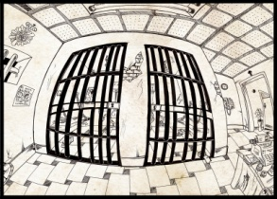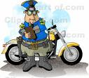
Señor Morales y Señorita Huber han robado el banco!!!
Se han escapado con 5 millones de euros pero la policía les está persiguiendo.
¿Quién acabará en la cárcel?
y...
¿Quién llegará a la isla desierta con los
5 millones de euros?
Señor Morales

Señorita Huber

**Teacher can change the story each time to test reading comprehension and can change it to suit grade level***

Sample Game Board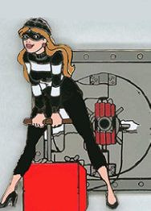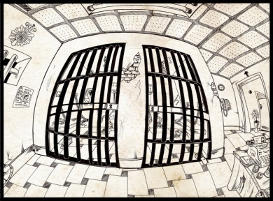

La Cárcel

La Isla
1
2
3
4
5
6
7
8
9
10
11
12
13
14
15
16
17
18

Policías y Ladrones

Student Assessment Checklist:

Nombre:_________________________________________
Fecha:___________________________________________

 | I don’t feel confident with these words and concepts | I feel confident with some of these words and concepts | I feel confident with all of these words and concepts
Family Members
Fruits
Vegetables
Spanish
Spanish speaking Countries
Animals

My best category was:____________________________________________________________

The category I still need the most help with is:_________________________________________

NEW WORDS TO ADD TO DICTIONARY:
WORDS I DON’T UNDERSTAND:

